 | 5.1.3 Topbar and Statusbar - Render menu
Table of content
Render Menu 2
Render Image 2
Render Animation 2
Mixdown Audio 2
Options 2
Relative Path 2
Accuracy 2
Containers 2
Format 2
Split Channels 2
OpenGL Render Image 3
OpenGL Render Animation 3
Show / Hide Render 3
Play rendered Animation 3
Lock Interface 3

Render Menu
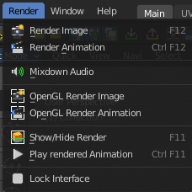
This menu contains functionality around rendering.
Most of the render settings can be found in the Properties editor in the Render tab. And here you can also choose the render engine.
Rendered images can be saved in the Image menu like any other image.

Render Image
Renders the current scene as an image by using the current chosen renderer.

Render Animation
Renders the current scene as an animation by using the current chosen renderer.

Mixdown Audio
Mixdown and export the scene's audio to an audio file. You will open an export dialog when you click at Mixdown Audio. Further Audio settings can be found in the Properties editor.

Options
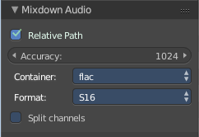
The options can be found down left in the Save dialog.

Relative Path
Select the file relative to the blend-file.

Accuracy
Sample accuracy, important for animation data (the lower the value, the more accurate).

Containers
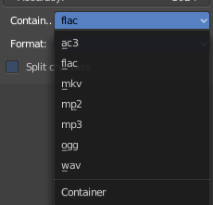
Choose between different audio export formats.

Format
Some Audio Containers also have option to choose a codec. For more information see here.

Split Channels
Each audio channel will be rendered into a separate file.

OpenGL Render Image
Renders an Image, using the Viewport OpenGL renderer.

OpenGL Render Animation
Renders an animation, using the Viewport OpenGL renderer.

Show / Hide Render
Toggles the display of the render view.

Play rendered Animation
Plays back the rendered animation sequence.

Lock Interface
Lock the interface while rendering to free the memory for the UI to the renderer.

